# **Name: Abdurrahman Qureshi**

# **Roll No: 210451**

Practical No: 3

**1)Demonstrate a Grid Layout of 5 x 5**

**CODE:**

import java.awt.*;

import java.awt.event.ActionEvent;

import java.awt.event.ActionListener;

public class Main extends Frame {

Main() {

Panel MainBody = new Panel();

MainBody.setLayout(new GridLayout(5,5,10,10));

for (int i = 1 ; i<=25 ; i++){

MainBody.add(new Button(String.valueOf(i)));

}

add(MainBody);

addWindowListener(new java.awt.event.WindowAdapter() {

public void windowClosing(java.awt.event.WindowEvent windowEvent) {

System.exit(0);

}

});

setFont(new Font("Comic Sans MS", Font.BOLD, 20));

setSize(500, 500);

setVisible(true);

setTitle("AJP Mixed Layout");

}

public static void main(String args[]) {

new Main();

}

}

**OUTPUT:**

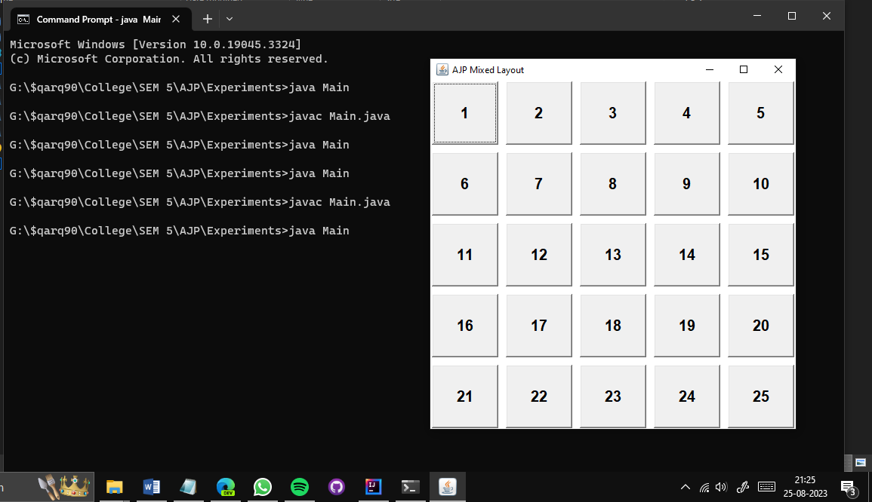

**2)Program to display numbers from 0 – 9 on buttons**

**CODE:**

import java.awt.*;

import java.awt.event.ActionEvent;

import java.awt.event.ActionListener;

public class Main extends Frame {

Main() {

Panel MainBody = new Panel();

MainBody.setLayout(new GridLayout(5,5,10,10));

for (int i = 0 ; i<=9 ; i++){

MainBody.add(new Button(String.valueOf(i)));

}

add(MainBody);

addWindowListener(new java.awt.event.WindowAdapter() {

public void windowClosing(java.awt.event.WindowEvent windowEvent) {

System.exit(0);

}

});

setFont(new Font("Comic Sans MS", Font.BOLD, 20));

setSize(500, 500);

setVisible(true);

setTitle("AJP Mixed Layout");

}

public static void main(String args[]) {

new Main();

}

}

**OUTPUT:**

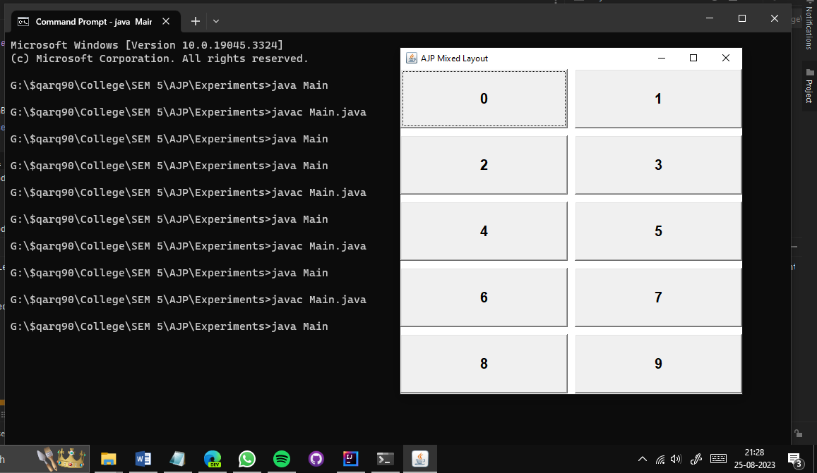

**3)Generate the following output**

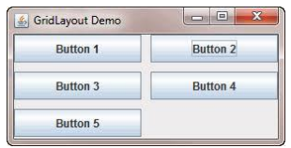

**CODE:**

import java.awt.*;

import java.awt.event.ActionEvent;

import java.awt.event.ActionListener;

public class Main extends Frame {

Main() {

Panel MainBody = new Panel();

MainBody.setLayout(new GridLayout(2,2,10,10));

for (int i = 1 ; i<=5 ; i++){

MainBody.add(new Button("Button "+String.valueOf(i)));

}

add(MainBody);

addWindowListener(new java.awt.event.WindowAdapter() {

public void windowClosing(java.awt.event.WindowEvent windowEvent) {

System.exit(0);

}

});

setFont(new Font("Comic Sans MS", Font.BOLD, 20));

setSize(500, 200);

setVisible(true);

setTitle("AJP Mixed Layout");

}

public static void main(String args[]) {

new Main();

}

}

**OUTPUT:**

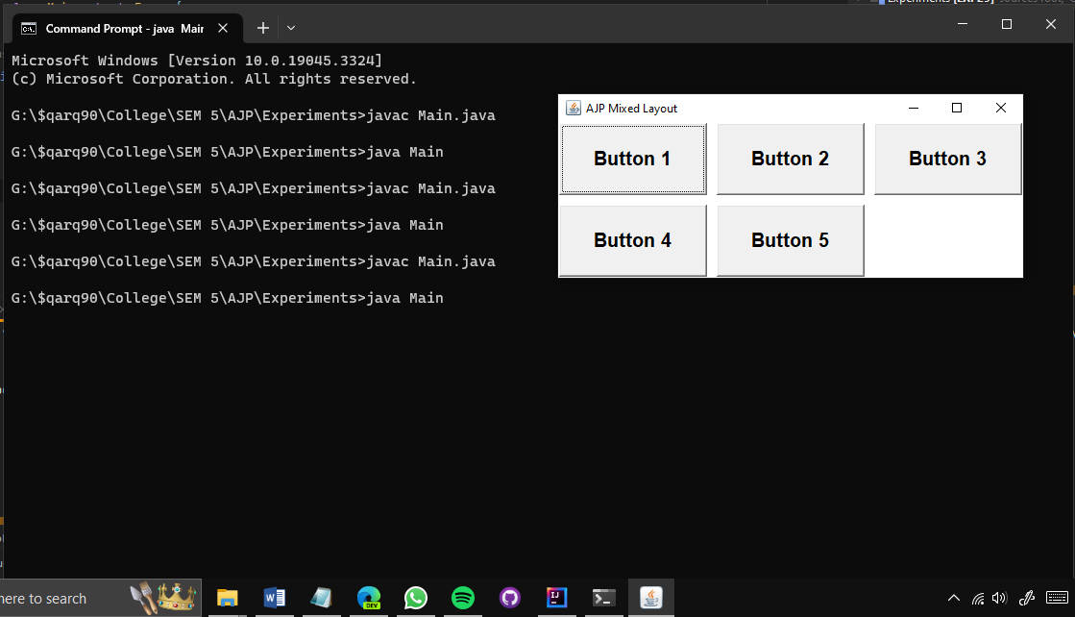

**4)Generate the following output**

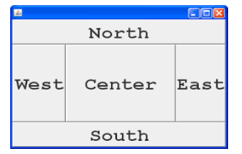

**CODE:**

import java.awt.*;

import java.awt.event.ActionEvent;

import java.awt.event.ActionListener;

public class Main extends Frame {

Main() {

Panel MainBody = new Panel();

MainBody.setLayout(new BorderLayout());

MainBody.add(new Button("NORTH"),BorderLayout.NORTH);

MainBody.add(new Button("SOUTH"),BorderLayout.SOUTH);

MainBody.add(new Button("CENTER"),BorderLayout.CENTER);

MainBody.add(new Button("EAST"),BorderLayout.EAST);

MainBody.add(new Button("WEST"),BorderLayout.WEST);

add(MainBody);

addWindowListener(new java.awt.event.WindowAdapter() {

public void windowClosing(java.awt.event.WindowEvent windowEvent) {

System.exit(0);

}

});

setFont(new Font("Comic Sans MS", Font.BOLD, 20));

setSize(500, 500);

setVisible(true);

setTitle("AJP Mixed Layout");

}

public static void main(String args[]) {

new Main();

}

}

**OUTPUT:**

